 | 10.1.15 Editors - Compositor Editor - Header - Add Menu - Utilities
Table of content
Detailed table of content 1
Add menu - Utilities 2
Map Range 3
Map Value 3
Math 4
Normalize 5
Levels 5
Split 6
Switch 7
Switch View 7

Detailed table of content
Detailed table of content
Detailed table of content 1
Add menu - Utilities 3
Map Range 3
Usage 4
Inputs 4
Value 4
From Min/Max 4
To Min/Max 4
Steps 4
Properties 4
Data Type 4
Interpolation Type 4
Clamp 4
Outputs 4
Value 4
Math 4
Inputs 5
Value 5
Value 5
Properties 5
Operation 5
Clamp 5
Outputs 5
Value 5
Mix 5
Inputs 5
Factor 5
Value A 6
Value B 6
Properties 6
Clamp Factor 6
Outputs 6
Result 6
Clamp 6
Inputs 6
Value 6
Properties 6
Clamp Type 6
Min / Max 6
Outputs 6
Value 6
Float Curve 7
Inputs 7
Value 7
Properties 7
Channel 7
Channel buttons 7
Curve edit field 7
Selecting Points 7
Adding Points 7
Navigation elements 7
Zoom in and out 7
Tools 7
Reset View 7
Vector Handle 8
Auto Handle 8
Auto Clamped Handle 8
Extend horizontal 8
Extend extrapolated 8
Reset Curve 8
Use Clipping 8
Delete Points 8
Outputs 8
Value 8
Levels 8
Inputs 8
Image 8
Properties 8
Channel 8
Outputs 9
Mean 9
Standard Deviation 9
Normalize 9
Inputs 9
Value 9
Outputs 9
Value 9
Split 9
Inputs 10
Image 10
Image 10
Properties 10
Axis 10
Factor 10
Outputs 10
Image 10
Switch 10
Properties 10
Switch 10
Inputs 10
Off 10
On 10
Image 10
Switch View 11
Inputs 11
Left 11
Right 11
Outputs 11
Image 11
Relative to Pixel 11
Inputs 12
Value 12
Image 12
Properties 12
Data Type 12
Reference Dimension 12
Outputs 12
Value 12

Add menu - Utilities

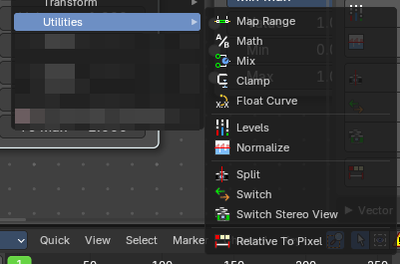
Here you find nodes that are used as utilities.

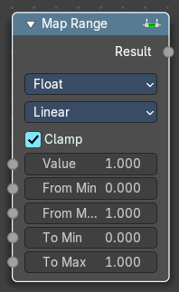
Map Range
This node allows to convert (map) an input value range into a destination range. By default, values outside the specified input range will be proportionally mapped as well. This node is similar to Map Value node but provides a more intuitive way to specify the desired output range.

Usage
One important use case is to easily map the original range of the Z-depth channel to a more usable range (i.e: 0.0 - 1.0) for use as a matte for colorization or filtering operations.

Inputs

Value
Standard value input.

From Min/Max
Start/End of the input value range.

To Min/Max
Start/End of the destination range.

Steps
The amount of steps.
Note: Only shows when using the Stepped Linear interpolation type.

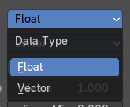
Properties

Data Type
Selects between float or vector values to map the range.

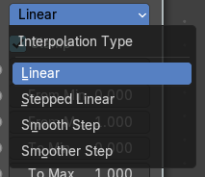
Interpolation Type
Selects between a linear, stepped linear, smooth step or smoother step interpolation types.

Clamp
Clamps values to Min/Max of the destination range.

Outputs

Value
Standard value output.

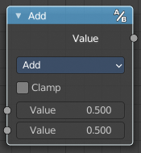
Math
The Math Node performs math operations.

Inputs

Value
First numerical value. The trigonometric functions accept values in radians.

Value
Second numerical value. This value is not used in functions that accept only one parameter like the trigonometric functions, Round and Absolute.

Properties

Operation
Here you can choose what mathematical operation to perform.
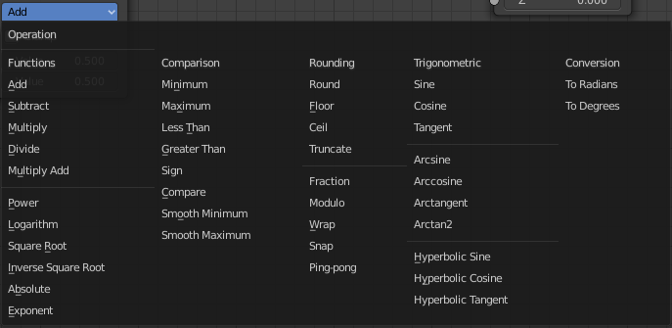

Clamp
Limits the output to the range (0 to 1). See clamp.

Outputs

Value
Numerical value output.

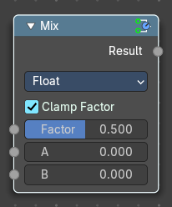
Mix
The Mix Node mixes float values by working on the individual and corresponding pixels of the two input values. Called “Mix” in the shader, Geometry Nodes and texture context.

Inputs

Factor
Controls the amount of influence the node exerts on the output Value.

Value A
The back value.

Value B
The top value.

Properties

Clamp Factor
Limit the highest color value to not exceed 1.

Outputs

Result
Value output.

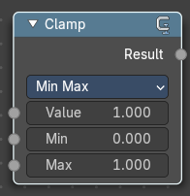
Clamp
The Clamp node restricts a value to lie within a specified range. It’s commonly used in compositing to prevent values from exceeding a desired minimum or maximum, which helps avoid unwanted brightness spikes or clipping in image processing.

Inputs

Value
Standard Value input. (Value refers to each vector in the set.)

Properties

Clamp Type
A dropdown that determines how the clamping is applied: Min / Max or Range.

Min / Max
The minimum and maximum allowed value. Any input lower or higher than this will be lowered or raised to this value.

Outputs

Value
Standard value output.

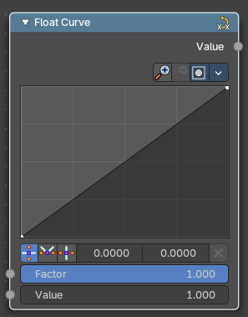
Float Curve
The Float Curves node maps an input value to a curve.

Inputs

Value
Standard float value input.

Properties

Channel

Channel buttons
X, Y, Z. Clicking on one of the channels displays the curve for each.

Curve edit field
Create and tweak a Bezier curve that varies the input levels (X axis) to produce an output level (Y axis).


Selecting Points
You can select curve points. This reveals two edit boxes for the x and y coordinate of this point.
Selected points can be moved around. Left click at them, hold the mouse button down and move them to a new location.


Adding Points
You can add new curve points by simply left clicking at the curve. Move the mouse to position them where you need it.

Navigation elements
The navigation elements at the top are described from left to right.

Zoom in and out
The two buttons with the magnifying glass at it zooms in and out in the curve window.

Tools

Tools is a menu where you can find some curve related tools.

Reset View
Resets the curve windows zoom.

Vector Handle
Set handle type to Vector.

Auto Handle
Set handle type to Auto.

Auto Clamped Handle
Set handle type to Auto Clamped.

Extend horizontal
Extends the curve before the first curve point and behind the last curve point horizontally.

Extend extrapolated
Extends the curve before the first curve point and behind the last curve point extrapolated.

Reset Curve
Resets the curve to the initial shape.


Use Clipping
Clipping options. Set up clipping for the stroke.

Delete Points
Deletes selected curve points.

Outputs

Value
Standard float value output.

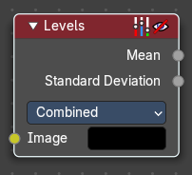
Levels
The Levels Node reads the inputs color channels and outputs analytical values. It’s useful for evaluating image brightness and contrast, and for driving effects based on image intensity.

Inputs

Image
The image input.

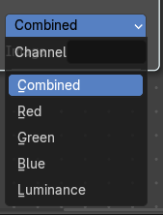
Properties

Channel
The Red, Green, Blue or Luminance channels

Outputs
1D values based on the levels of an image.

Mean
The mean is the average value of all image pixels in specified channel (combined, red, green, blue, luminance). It tells you how dark or bright the image is and can be used as such for setups that depend on how is input “bright” or “dark”.

Standard Deviation
How much those pixel values differ from the mean. A low standard deviation indicates that the pixel values tend to be very close to the mean. A high standard deviation indicates that the values are spread out over a large range of values.
The visualization of such data is just a gray rectangle.

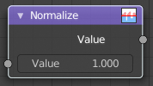
Normalize
Find the minimum and maximum values of a single channel. Then map the values to a range of 0 and 1.

Inputs

Value
Standard value input.

Outputs

Value
Standard value output.

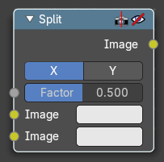
Split
Allows to combine two images horizontally or vertically

Inputs

Image
The first image.

Image
The second image.

Properties

Axis
If to split the image horizontally or vertically.

Factor
How much percent the first image or the second image is visible.

Outputs

Image
Image output.

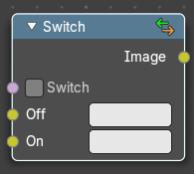
Switch
The Switch node is akin to a boolean, where you can use a toggle to choose what is shown with on or off.

Properties

Switch
The toggle that turns the switch on or off resulting in the final output being whatever is in the on or off input.

Inputs

Off
The image that is shown when the toggle is off.

On
The image that is shown when the toggle is on.

Image
Standard RGB image output.

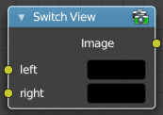
Switch View
The Switch View node combines the views (left and right) into a single Stereo 3D output. This can be useful if for example, you need to treat the view as separate images by combining each of the views.

Inputs

Left
Left-eye image input.

Right
Right-eye image input.

Outputs

Image
Stereo 3D image output.

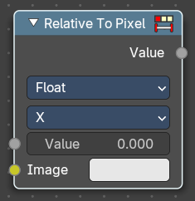
Relative to Pixel
The Relative to Pixel node converts values expressed as relative factors (e.g., percentages of image size) into absolute values. This is especially useful when working with nodes that require pixel-based inputs, such as filters or masks, while still allowing for resolution-independent setups.
Example: Converting a Value of 10 Using “Per Dimension”
Let’s say you’re working with an image that’s 1920 pixels wide and 1080 pixels tall with the following input value and properties.
- Mode: Per Dimension
- Input Value: 10% (or 0.10 as a relative value)
- Value Type: 2D Vector (0.10, 0.10)
Using Per Dimension type, each component of the vector is multiplied by its respective X and Y image dimension:
- X = 0.10 × 1920 = 192 pixels
- Y = 0.10 × 1080 = 108 pixels
Resulting Pixel Value: (192, 108)

Inputs

Value
The input float value to convert. This would be your absolute value.

Image
The reference image used to determine pixel dimensions. If not connected, the active compositing image is used.

Properties

Data Type
Specifies whether the input is a Float or a Vector. This affects how the conversion is applied.

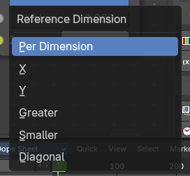
Reference Dimension
Determines how the relative value is interpreted.
- Per Dimension: Converts each component (X and Y) relative to its corresponding image dimension.
- X: Converts the value relative to the image width.
- Y: Converts the value relative to the image height.
- Greater: Uses the larger of the image’s width or height as the reference.
- Smaller: Uses the smaller of the image’s width or height.
- Diagonal: Uses the diagonal length of the image as the reference.

Outputs

Value
The converted float value, based on the selected mode and input type.

